Faculty Profile

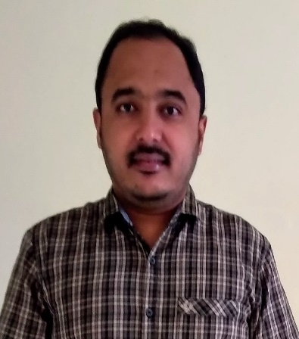 | Dr. Rajesh Kumar Dhanaraj  Designation: Professor  Qualification:  B.E (Computer Science and Engineering)  M.Tech (Information Technology)  Ph.D (Computer Science and Engineering)  Email: sangeraje@gmail.com rajesh.dhanaraj@sicsr.ac.in
Research Interests & Expertise:
Broad areas:
- Artificial Intelligence and Machine Learning
- Security and Cyber Physical System

Specific areas:
- Multimodal AI
- Deep Learning
- Computational Intelligence
- Zero Trust Security

Research Profiles: | [Google Scholar]  [ORCID]  [Researcher ID]  [Vidwan]
~~~~~~~~~~~~~~~~~~~~~~~~

